**Create a dataset which contains all the data in child plus a new column “ageGroup” with values “Five and under” and “6 and over”. Use one or more visualizations to compare the standard score against the cost for each age group. The visualization(s) should also show whether there was a family history of autism. Comment on your visualizations.**

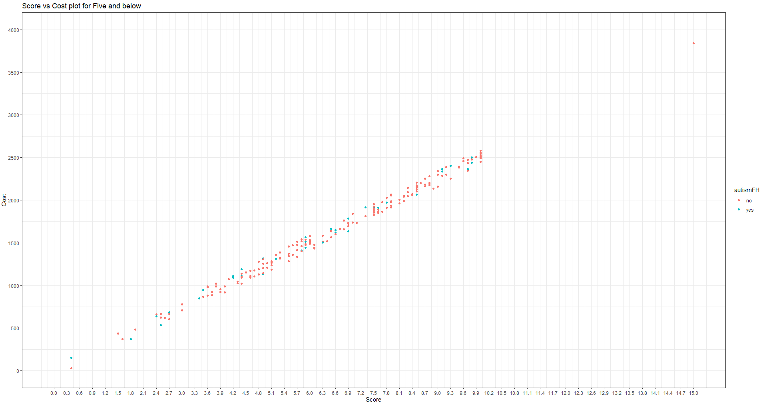

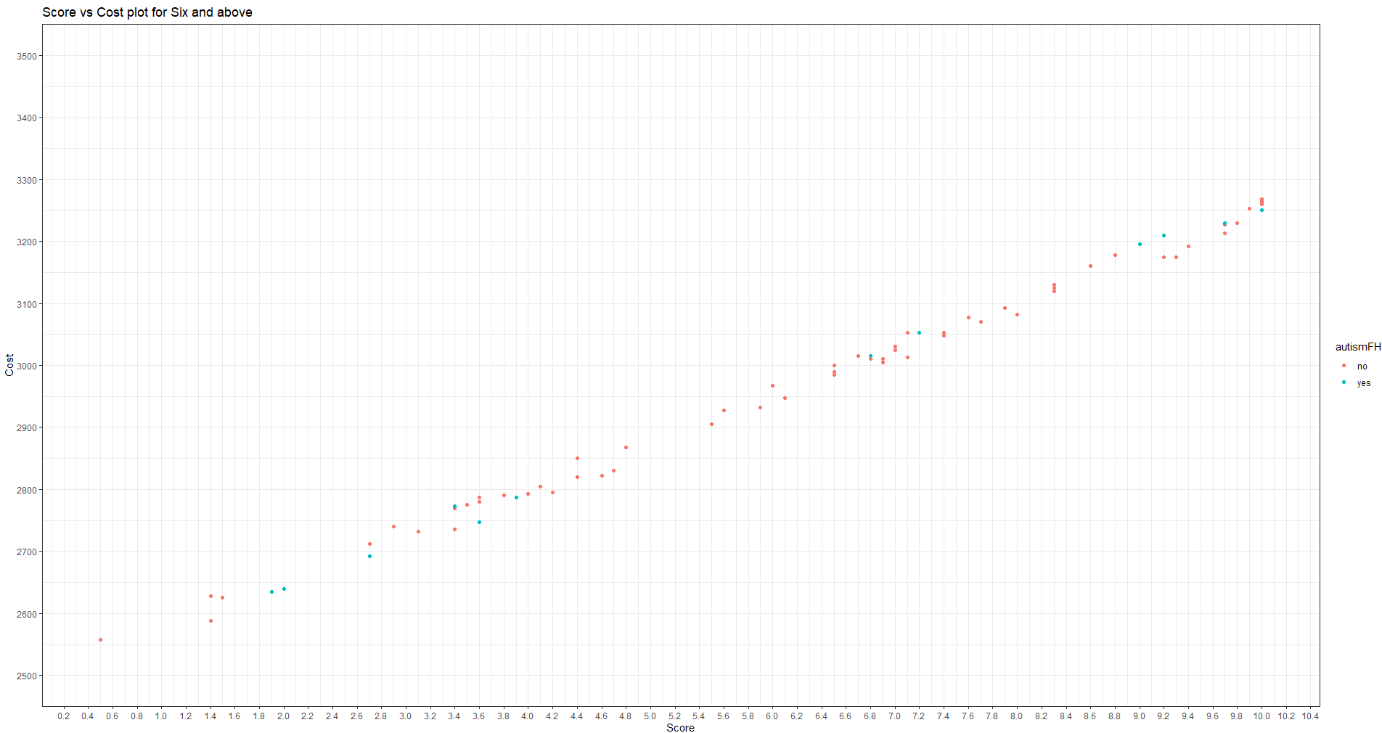

The graph show a compairism between the score and cost of the child data source. The graph shows that there are more children with autism for those of five and below than there are for those of six and above based on the data soucre available. It also show an increase in cost as the score increases.